School Club Database Management System Documentation

Introduction and Project Overview

This document provides comprehensive documentation for the Victory School Club Database Management System, a web-based application designed to streamline and enhance the management of school clubs. This system empowers club administrators with robust tools to manage club members, organize events, and efficiently maintain crucial club data. By leveraging the power of a database management system, this project aims to simplify club operations, promote efficient communication, and foster a more organized and engaging club experience for both students and administrators.

# System Architecture and Technologies

The Victory School Club Database Management System is built on a client-server architecture, utilizing a combination of front-end and back-end technologies to deliver a seamless user experience.

|  |  |
| --- | --- |
| Frontend | Backend |

HTMLNode.js

CSSExpress.js

JavaScriptSQLite3

Backend

* EXPRESSJS
* SQLITE3 For Database
* NodeJS

# Database Design and ER Diagram

The core of the system lies in the schoolClub.db database, a SQLite3 database meticulously designed to store and manage all essential club data. An Entity-Relationship (ER) diagram illustrates the relationships between the different entities in the database.

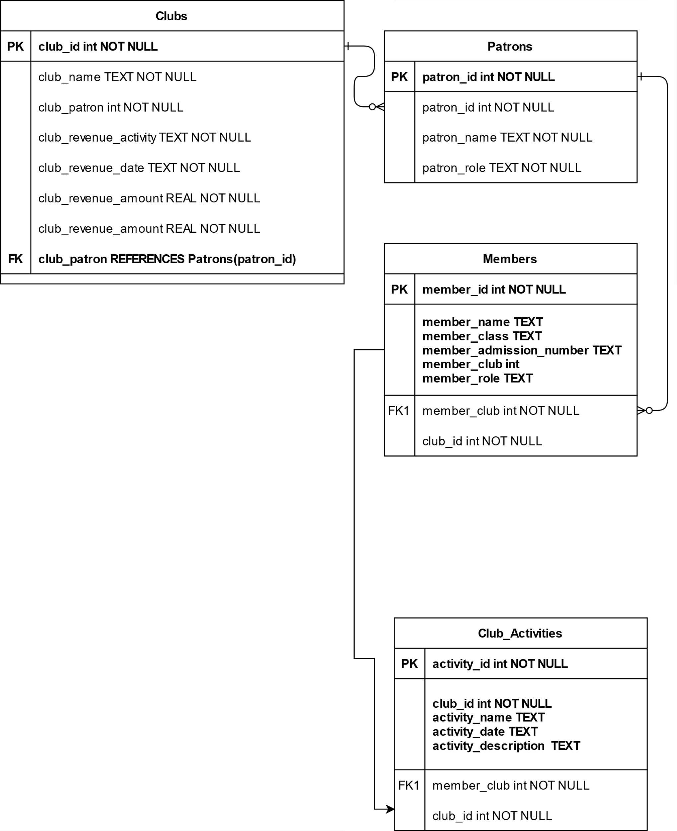

# Backend Services and Functionality

The backend services are handled by the server.js file, which acts as the central hub for database interaction and application logic. Key backend functionalities include:

Member Management: Add, edit, and delete club members, track membership status, and maintain contact information.

Event Management: Create, update, and delete club events, including details like date, time, location, and descriptions.

Data Access and Retrieval: Provide secure access to club data for authorized administrators, allowing them to generate reports and analyze information.

Security and Authentication: Ensure secure access to the system and protect sensitive club data.

# Frontend User Interface and Features

The user interface is designed to be intuitive and user-friendly, providing a seamless experience for club administrators to manage club data. Key features include:

Dashboard: A centralized hub providing an overview of club activity, including recent events, member updates, and key metrics.

Member Management Panel: Enables administrators to add, edit, and delete club members, view member profiles, and manage membership status.

Event Management Panel: Allows administrators to create, edit, and delete club events, including details like date, time, location, and descriptions.

Reporting and Analytics: Provides tools for generating reports on club activity, membership trends, and event attendance.

# User Roles and Permissions

The system implements a role-based access control system to ensure that only authorized users have access to specific data and functionalities. Two primary user roles are defined:

Club Administrator: Full access to all features, including managing members, events, and data.

Club Member: Limited access to view event information and club details.

# Data Management and Reporting

The system provides robust data management capabilities, allowing administrators to effectively organize, analyze, and report on club data. Key features include:

Data Import/Export: Enables administrators to easily import and export club data in various formats, such as CSV and Excel.

Data Validation: Enforces data integrity by implementing data validation rules to ensure accurate and consistent data entry.

Reporting Tools: Offers a range of pre-built reports and customizable reporting templates for generating insights into club activities and membership trends.

# Security and Privacy Considerations

Security and privacy are paramount in the design and development of the system. The following measures are implemented to safeguard user data and ensure responsible data management:

Secure Authentication: Implements secure login credentials and password management practices to prevent unauthorized access.

Data Encryption: Encrypts sensitive data at rest and in transit to protect it from unauthorized access.

Data Backup and Recovery: Implements regular data backups and recovery procedures to minimize data loss in case of system failures or security breaches.

Privacy Policy: Clearly outlines data collection practices, user rights, and data usage policies to ensure transparency and user trust.

# Deployment and Hosting

The system will be deployed on a secure server infrastructure, ensuring high availability and reliable performance. The choice of hosting provider will depend on factors such as budget, scalability requirements, and security considerations. Continuous monitoring and maintenance will be implemented to ensure the system remains up-to-date, secure, and performs optimally.